HF 37: Freedom of expression and freedom of the media in North Macedonia
“Horizontal Facility for the Western Balkans and Turkey II”

Launching of the HELP online course on
Freedom of expression

Draft Agenda
Skopje, 29 September 2021

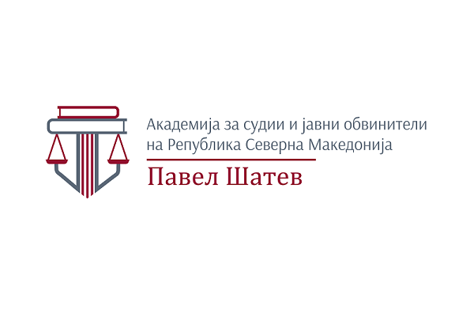
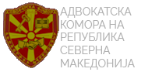
Moderator: Aleksandra Bogdanovska, Senior Project Officer, Programme Office of the Council of Europe in Skopje

09:30–10.00 Testing participants’ connections
10.00–10.20 Welcoming addresses
Natasa Gaber-Damjanovska, Director of the Academy for Judges and Public Prosecutors

Ljubomir Mihajlovski, President of the North Macedonia Bar Association

EUD representative (TBC)

Cezare Pitea, Programme Manager, Division for Cooperation on Freedom of expression, Information Society Department, CoE Strasbourg (TBC)

10.20-10.35 Freedom of expression and freedom of the media in North Macedonia
Cezare Pitea, Programme Manager, Division for Cooperation on Freedom of expression, Information Society Department, CoE Strasbourg (TBC)
10.35-11.00 The Council of Europe Programme for Human Rights Education for Legal Professionals (HELP): an introduction to the online course on Freedom of expression
Ana Medarska-Lazova, HELP Secretariat, Council of Europe (TBC)
Valentina Boz, HELP in the Western Balkans, Directorate General of Human Rights and Rule of Law (DGI), Council of Europe (TBC)
11.00-11.20 Overview of the recent case law of the European Court of Human Rights/domestic courts related to freedom of expression
Proposed tutor from the AJPP
11.20-11.40 Legal development in the area of freedom of expression
Jelena Ristikj, Vice-President of the Bar Association of North Macedonia – National tutor of the HELP online course on Freedom of expression

11.40-11.50 Practical aspects of the course implementation
- presentation of the tutors and their role
- adaptation to the domestic legal context
- registration to the CoE HELP platform
- enrolment to the course
- clarification of participants’ tasks
- Q and A
Moderated by Jelena Ristikj and XXX, HELP tutors

11.50-12.00 Closing remarks
Cezare Pitea, Programme Manager, Division for Cooperation on Freedom of expression, Information Society Department, CoE Strasbourg (TBC)

